

202304409 -202301996 -202304254 - 202301649 -202301714
Elias Hasan - Ebrahim Emad - Ali Alqallaf - Mohamed Altaitoon - Salman Alghazal

Task 1 Problem Statement Formulation and Definition 16
1.1 Motivation 16
1.2 Objectives 17
1.3 Problem Statement 17
1.4 Expected Results 17
Task 2 Data Collection and Selection 17
2.1 Dataset Source and Justification 17
2.2 Dataset Overview 17
2.3 Attribute Analysis 18
2.4 Missing and Redundant Data 18
2.5 Data Visualizations and Distribution Analysis 19
Task 3 Data Preparation and Pre-processing 22
3.1 KDD Process Overview 22
3.2 Handling Missing and Redundant Data 23
3.3 Feature Engineering Vehicle Location Parsing 24
3.4 Stratified Sampling 24
3.5 Data Distribution Before and After Preprocessing 24
3.6 Outlier Detection 25
3.7 Principal Component Analysis (PCA) 27
Task 4 Building Data Mining Models 30
4.1 Data Split 30
4.2 Models and Parameters 30
4.3 Pipeline and Multiply Operators 30
4.4 Decision Tree Parameters 31
4.4b Naive Bayes Parameter Configuration 32
4.5 Vote Ensemble Sub-process 33
4.6 Decision Tree Learned Rules 34
Task 5 Evaluating Data Mining Models 35
5.1 Metrics Justification 35
5.2 Decision Tree 35
5.3 Naive Bayes 37
5.4 Vote Ensemble 38
5.5 Model Comparison 39
5.6 Complete RapidMiner Process 40
Task 6 Inferences, Recommendations and Reflection 40
6.1 Model Comparison and Inferences 41
6.2 Business Impact 41
6.3 Recommendations 41
6.4 Reflection 42

Task 1 Problem Statement Formulation and Definition

1.1 Motivation
Washington State tops US states in Electric Vehicle registrations. Amongst all the eligible electric vehicles only 20% of them are PHEV and just 54% of PHEV qualify for CAFV incentive The state is now adopting the California zero-emission vehicle standard. There requires a fine balance for manufacturers in the production of BEV and PHEV. If they mistakenly guess, they could be impacted by supply chain issues and lose out on the incentives. Earlier analysis targeted geographic concentration. However, nobody has investigated the supervised ensemble classification approach to establishing the best way to produce these vehicles yet. This project tries to do exactly that by building and comparing a few classifiers like Decision Tree, Naive Bayes, and Vote Ensemble to see which one performs. Researchers mainly clustered EVs by location in the dataset from previous works. No one has really applied supervised classification to the production aspect of the process and this project is trying to fill that gap.

1.2 Objectives
- Identify and analyse battery range characteristics across BEV and PHEV vehicle types to determine key differentiating thresholds
- Compare and classify CAFV eligibility categories to understand the distribution of clean fuel incentive-qualifying vehicles
- Identify whether electric utilities are well-distributed across the Washington State EV fleet
- Build and evaluate classification models capable of predicting Electric Vehicle Type from available registration attributes

1.3 Problem Statement
Electric vehicle registration in Washington State indicates imbalances which impede production optimisation. 20% of registrations represent plug-in hybrids and 54% represent clean alternative fuel vehicles, which evidences absence of distinguishing metrics. This project applies data mining classification to identify electric range as the feature which differentiates battery electric vehicles from plug-in hybrids.

1.4 Expected Results
Three classification models are expected to exceed 99% accuracy. The Decision Tree should identify Electric Range as the dominant feature, with the Vote Ensemble achieving the highest generalisation accuracy on unseen data.

Task 2 Data Collection and Selection

2.1 Dataset Source and Justification
I retrieved the Electric Vehicle Population Data from the Washington State Department of Licensing on Kaggle. This was chosen as it meets all the project goals - containing Electric Range, CAFV eligibility and electric utility data for every registered EV in Washington State. This data comes from a verified government source and can be used for production analysis.

2.2 Dataset Overview
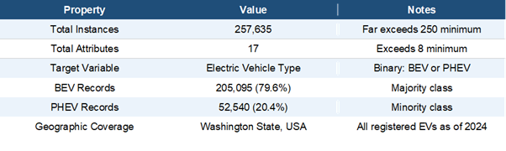
Table 2.1: Dataset overview and key properties

2.3 Attribute Analysis
The dataset contains 17 attributes spanning qualitative (nominal/ordinal) and quantitative (discrete/continuous) types. Table 2.2 shows the complete attribute inventory with each attribute's role in the analysis.
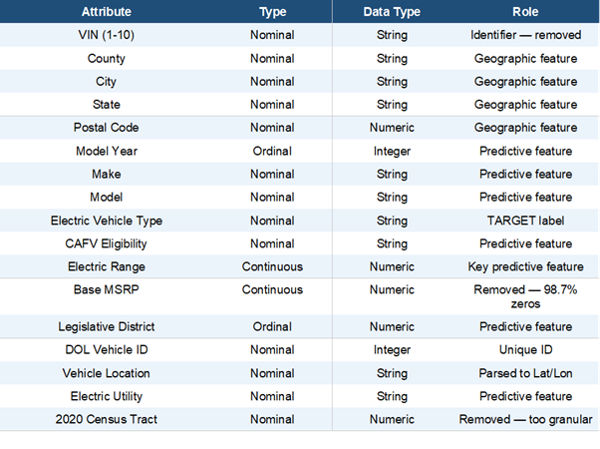
Table 2.2: Complete attribute inventory — green row = target label

2.4 Missing and Redundant Data
The dataset contains data quality issues requiring preprocessing. Table 2.3 summarises all identified issues and actions taken.

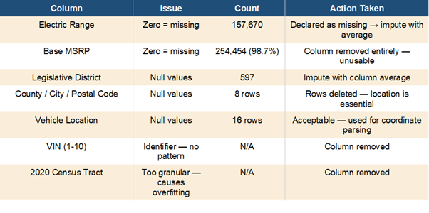
Table 2.3: Data quality issues and actions taken in preprocessing

2.5 Data Visualizations and Distribution Analysis
The following visualisations show the dataset distribution before preprocessing.

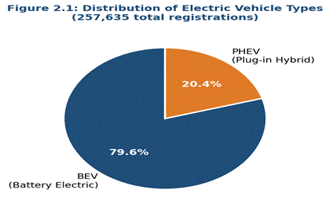
Figure 2.1: EV type distribution — 79.6% BEV (205,095) vs 20.4% PHEV (52,540). This 80/20 imbalance directly influenced evaluation metric selection in Task 5.
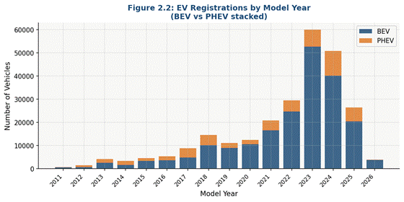
Figure 2.2: EV registrations by model year (stacked BEV/PHEV). BEV dominance accelerates from 2020 onwards, peaking in 2023 with 60,042 registrations.
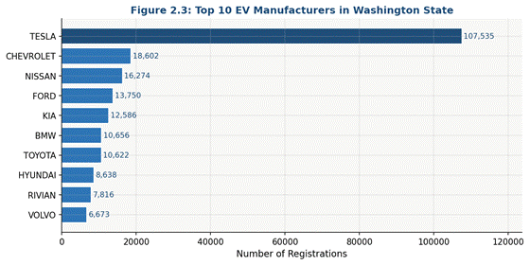
Figure 2.3: Top 10 EV manufacturers. Tesla dominates with 107,535 registrations (41.7%), followed by Chevrolet (7.2%), Nissan (6.3%) and Ford (5.3%).
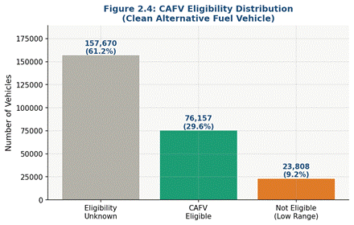
Figure 2.4: CAFV eligibility — 61.2% unknown, 29.6% eligible, 9.2% ineligible due to low battery range.
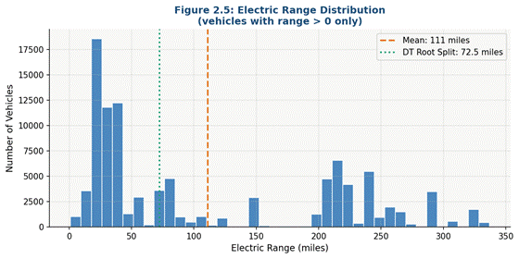
Figure 2.5: Electric Range distribution (range > 0). Right-skewed, mean 111.2 miles. The DT root split at 72.5 miles cleanly separates BEV from PHEV.
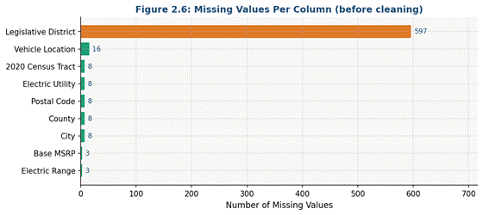
Figure 2.6: Missing values per column before preprocessing. Legislative District has 597 nulls; Base MSRP and Electric Range zeros handled as declared missings.
The 80/20 BEV/PHEV imbalance directly influenced metric selection in Task 5. Electric Range is the most discriminating feature BEVs have consistently higher ranges, explaining why the Decision Tree root split at 72.5 miles achieves near-perfect classification.

Task 3 Data Preparation and Pre-processing
The preprocessing pipeline was built in Altair AI Studio following the KDD process. Each operator applied a specific transformation, moving the raw dataset toward a clean, model-ready state.

3.1 KDD Process Overview
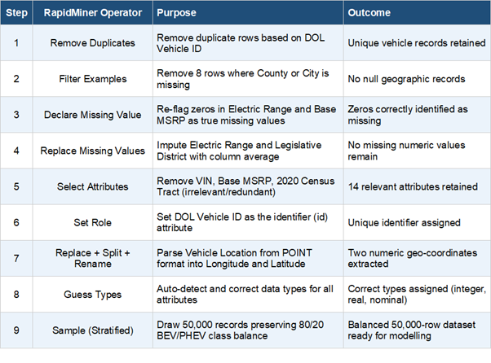
Table 3.1: KDD pipeline — each RapidMiner operator, its purpose and outcome in the preprocessing workflow

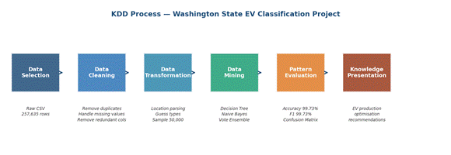
Figure 3.0: KDD process — six-stage architecture (Data Selection → Cleaning → Transformation → Mining → Evaluation → Knowledge Presentation) applied to the Washington State EV Classification project

3.2 Handling Missing and Redundant Data
Missing-value zeros in Electric Range and Base MSRP, re-flagged by Declare Missing Value, received column-mean imputation for Electric Range and Legislative District via Replace Missing Values; eight null County/City rows were deleted and Select Attributes removed VIN and Base MSRP and 2020 Census Tract.

3.3 Feature Engineering Vehicle Location Parsing
Vehicle Location was stored as POINT (-122.3 47.6) format. A Replace operator extracted coordinates, Split separated them into Longitude and Latitude, and Rename/Guess Types finalised both as decimal numeric attributes.

3.4 Stratified Sampling
The cleaned data consisting of 257635 rows was used to extract 50000 rows through stratified sampling maintaining the natural BEV/PHEV ratio of 80/20. The absence of stratification would result in the minority PHEV class being underrepresented and create a bias toward the model training for the majority class.

3.5 Data Distribution Before and After Preprocessing
Electric Range as generated in Altair AI Studio is shown in Figures 3.1a and 3.1b. Before cleaning, the distribution has 157,670 zeros (61.2%). The spike after imputation with the non-zero column mean (111.2 miles) shifts to ~111 miles indicating that the operator worked correctly.

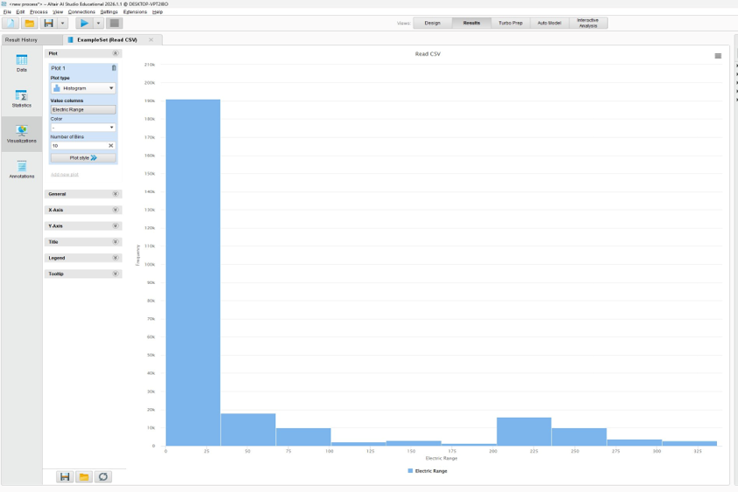
Figure 3.1a: Electric Range BEFORE preprocessing Altair AI Studio histogram from raw 257,635-row dataset. Dominant spike at 0 represents 157,670 rows with zero Electric Range.

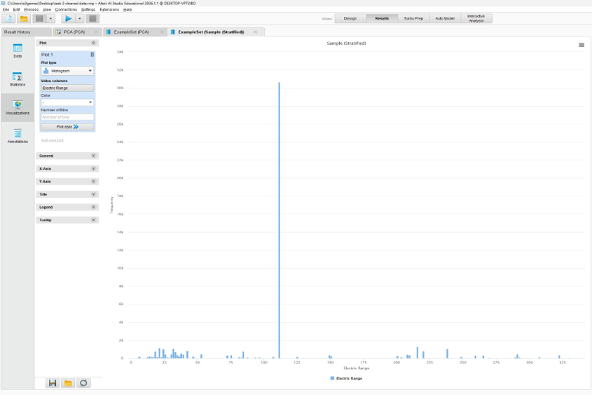
Figure 3.1b: Electric Range AFTER preprocessing Altair AI Studio histogram from cleaned 50,000-row dataset. Spike at ~111 miles represents all imputed values replaced with the non-zero mean.

3.6 Outlier Detection
Box plots in Figures 3.2a–c show Electric Range outliers to 337 miles (valid long-range Tesla models), Model Year lower outliers (pre-2010 legacy records), and a well-distributed Legislative District (min 1, median 32, max 49). No records were removed.

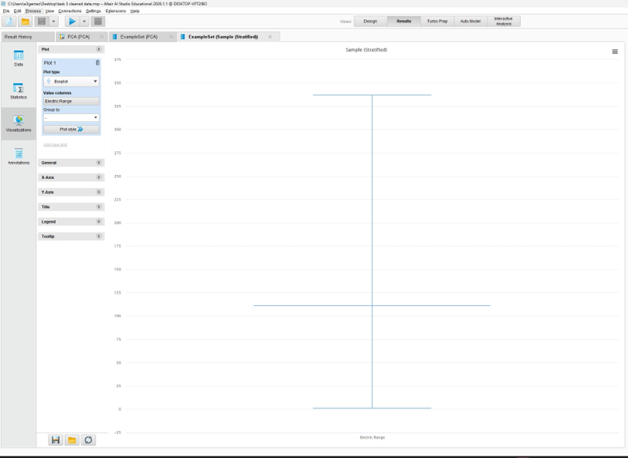
Figure 3.2a: Electric Range box plot skewed distribution with upper outliers to 337 miles (long-range Tesla models). All outliers retained as valid data.

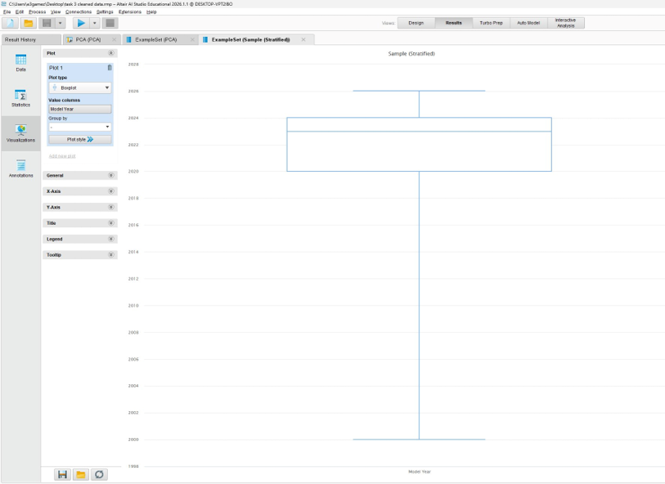
Figure 3.2b: Model Year box plot IQR approximately 2020–2024, with lower outliers representing pre-2010 legacy registrations retained as valid records.

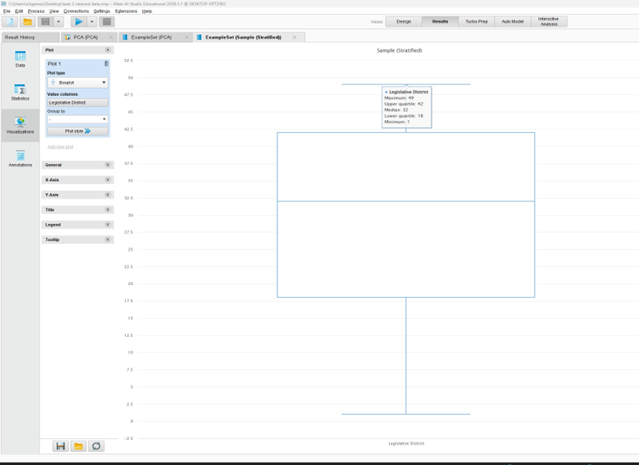
Figure 3.2c: Legislative District box plot range 1–49, median 32, IQR 18–42. Well-distributed with no outlier removal required.

3.7 Principal Component Analysis (PCA)
PCA was applied to 6 numeric features with a 95% variance threshold. PC1 alone explains 99.9% of variance (eigenvalue 2535.923), confirming Electric Range dominates the numeric feature space.

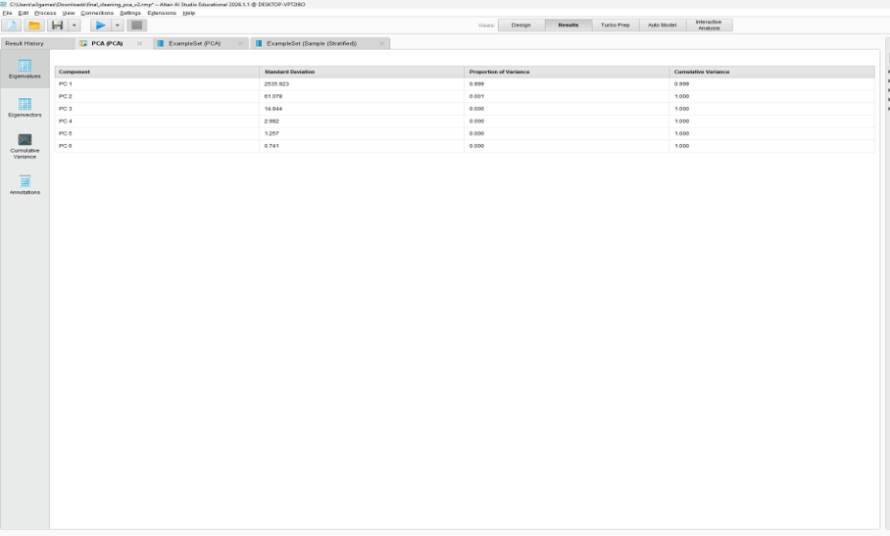
Figure 3.3: PCA Eigenvalues table — PC1 Standard Deviation 2535.923, explains 99.9% of total variance. Only 1 component needed to exceed the 95% threshold.

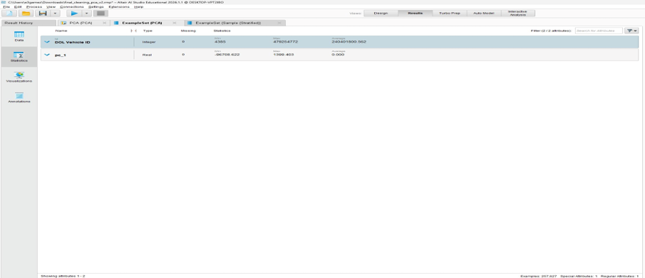
Figure 3.4: ExampleSet (PCA) — 6 numeric features reduced to 1 principal component (pc_1) retaining 99.9% of variance.

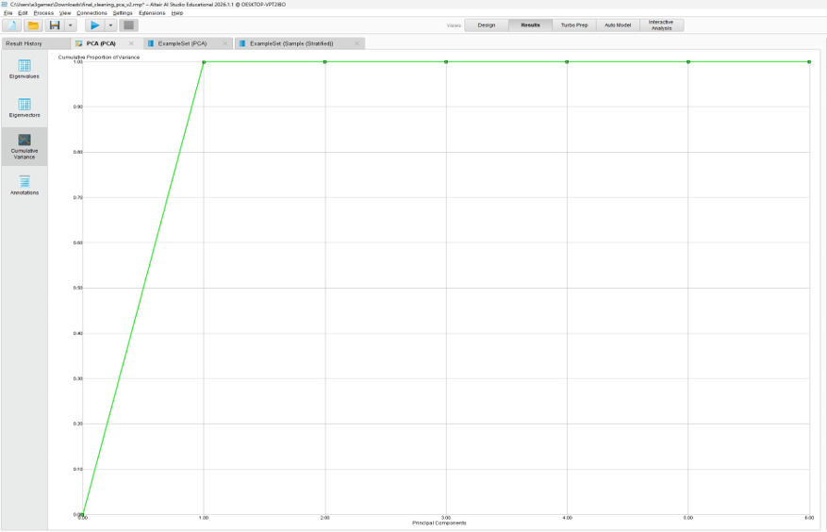
Figure 3.5: Cumulative variance chart — PC1 alone reaches 1.0, confirming a single component captures essentially all numeric variance.

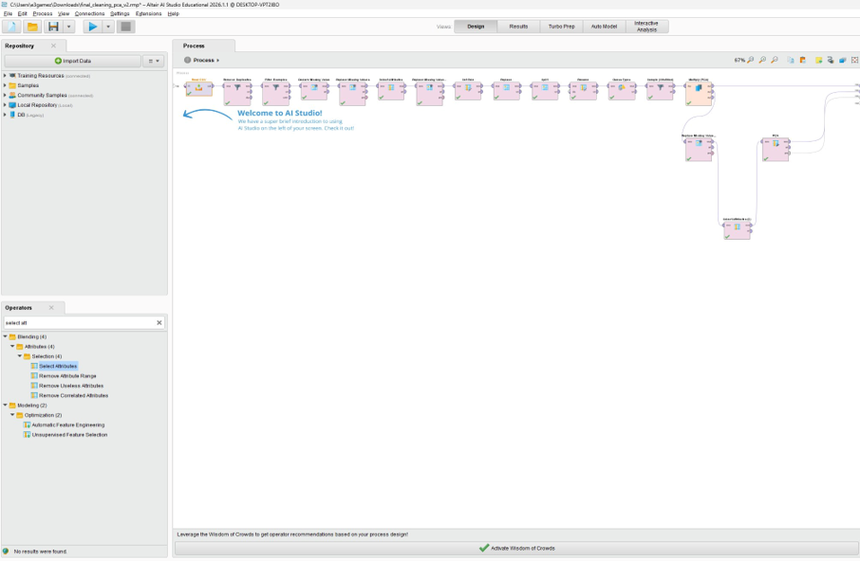
Figure 3.6: Complete Task 3 pipeline showing the PCA analysis branch (bottom) alongside the main cleaning and sampling pipeline (top).

Note :

The PCA was not used for Task 4 as it would have lost useful category features such as Make, Model, and County. Those are for the edge cases. Also, Electric Range would have been replaced with something vague. The threshold of 72.5 miles is necessary. PCA used to explore in task 3. Electric Range is shown to be an important numeric feature, which reaffirms its significance.

Task 4 Building Data Mining Models

4.1 Data Split
The stratified sampling partitioning of the 50,000 row dataset maintains the 80/20 BEV/PHEV ratio and yields 70/20/10 subsets, whereas 80/20 was rejected for lack of validation and 60/20/20 for reducing training data; three models trained on identical partitions which were generated via Multiply operators.

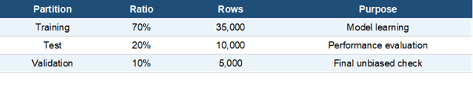
Table 4.1: Data split ratios and purpose

4.2 Models and Parameters
Three supervised classifiers were built to predict Electric Vehicle Type. Decision Tree for interpretability using gain_ratio. Naive Bayes as probabilistic contrast with laplace correction. Vote Ensemble combines both via majority voting.

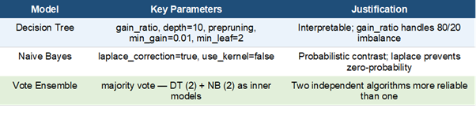
Table 4.2: Models, parameters and justification

4.3 Pipeline and Multiply Operators
The Multiply operators in Figure 4.1 are what keeps the comparison fair they push the exact same data to all three models at once, so no model had an advantage over another.

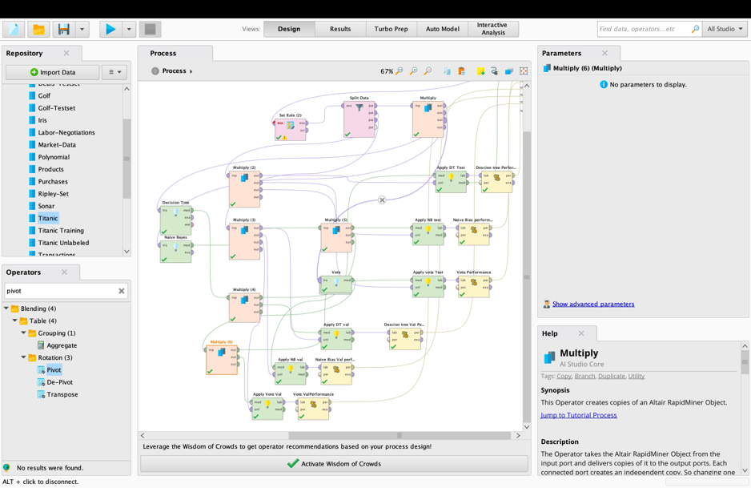
Figure 4.1: Complete Task 4 pipeline — Set Role, Split Data, and Multiply operators distributing partitions to Decision Tree, Naive Bayes and Vote Ensemble branches.

4.4 Decision Tree Parameters
As illustrated in Figure 4.2, using gain_ratio was more logical. With 80% of the data being BEV, the standard metric would have been biased towards the majority class. The tree had enough space to learn and not memorise the training data for depth 10.

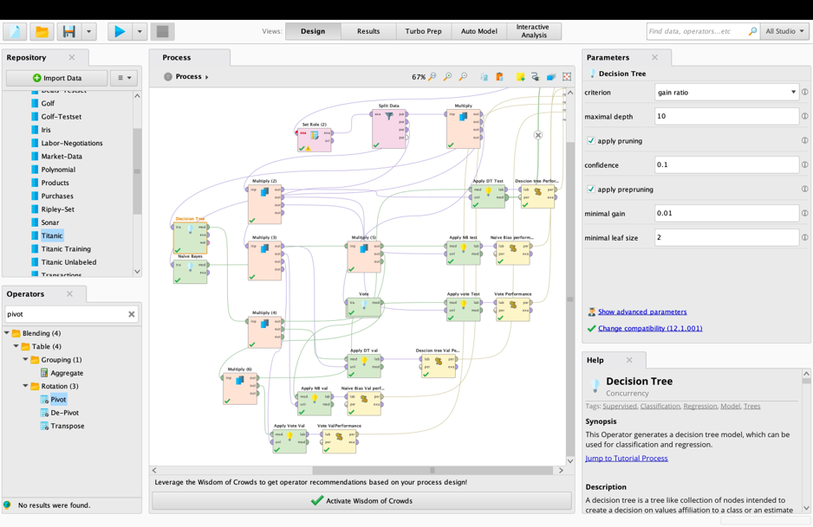
Figure 4.2: Decision Tree parameter panel — criterion=gain_ratio, maximal depth=10, prepruning=true, minimal gain=0.01, minimal leaf size=2.

4.4b Naive Bayes Parameter Configuration
Laplace correction in Figure 4.3 was important to keep in. Without it, a single feature value the model never saw during training would've wiped out the entire class probability — basically breaking the prediction.

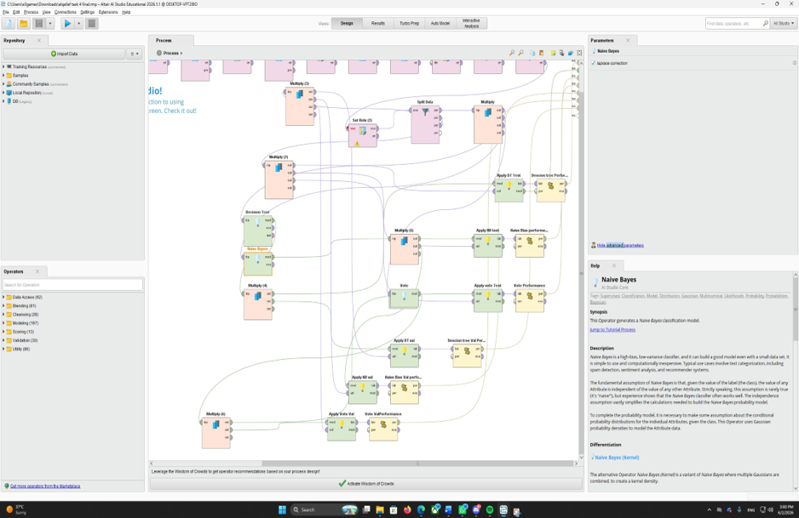

Figure 4.3: Naive Bayes parameter panel — laplace correction enabled (ticked), use_kernel disabled.

4.5 Vote Ensemble Sub-process
Inside Vote operator is represented in the Fig 4.4. The two learners Decision Tree and Naive Bayes each train on their own and make their own predictions. The final answer comes from the choice with the most votes.

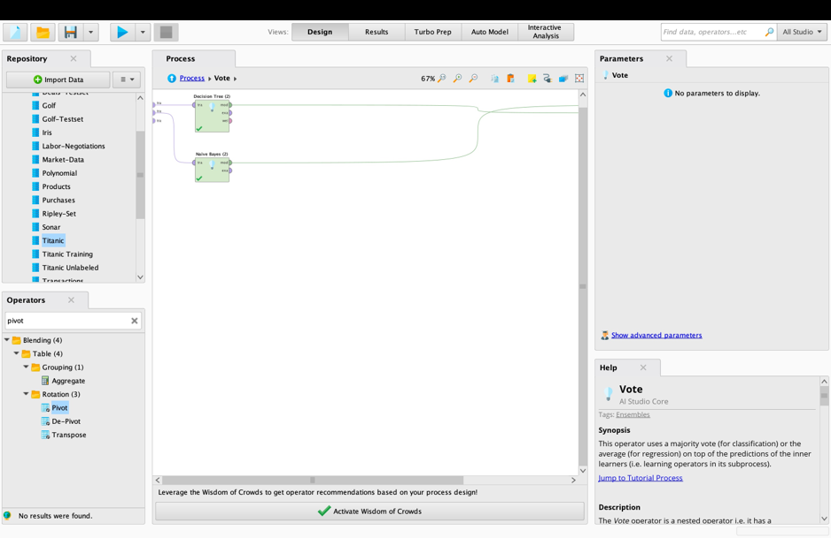
Figure 4.4: Vote Ensemble inner sub-process — Decision Tree (2) and Naive Bayes (2) connected to training input and model output ports.

4.6 Decision Tree Learned Rules
Looking at Figure 4.5, the tree made its decision clear from the very first split. Electric Range above 72.5 miles and the vehicle is almost certainly a BEV. Anything below that gets a second look using Model Year and Make to handle the edge cases.

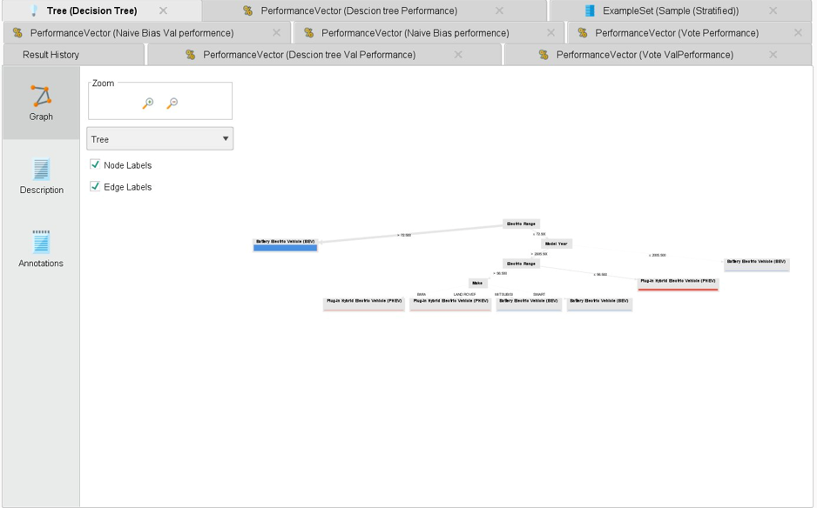
Figure 4.5: Decision Tree visual diagram — root split at Electric Range > 72.5, followed by Model Year and Make as secondary splits.

Task 5 Evaluating Data Mining Models

5.1 Metrics Justification
We examined the accuracy, precision, recall, F1 score, and confusion matrix to assess performance. Given the classes are imbalanced, with the 80/20 BEV/PHEV class imbalances, accuracy is not reliable. Weighted F1 is more effective than accuracy for imbalanced classes since it combines precision and recall. The Decision Tree achieves 99.73%, Naive Bayes 99.60%, and voting ensemble 99.73%.

5.2 Decision Tree
The Decision Tree achieved 99.73% test and 99.78% validation accuracy. It misclassified only 6 PHEVs as BEV across 51,386 test examples. BEV recall reached 99.99%. The tree diagram confirms Electric Range over 72.5 as the dominant root split.

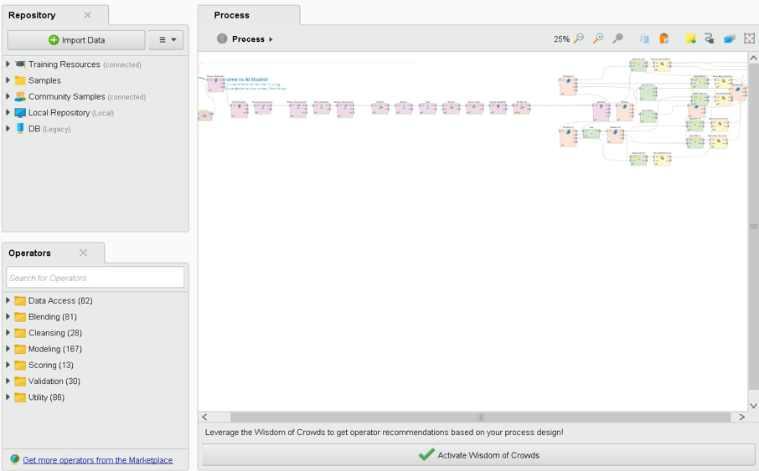
Figure 5.1: Decision Tree test performance — 99.73% accuracy (51,386 test examples, 6 PHEV misclassified).

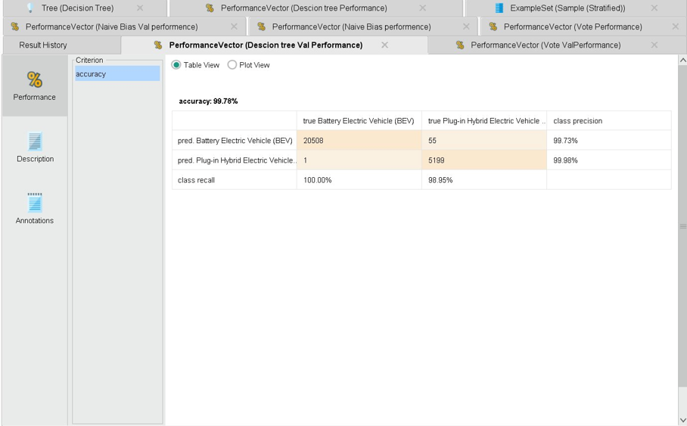
Figure 5.2: Decision Tree validation performance — 99.78% accuracy (25,763 validation examples, 1 PHEV misclassified).

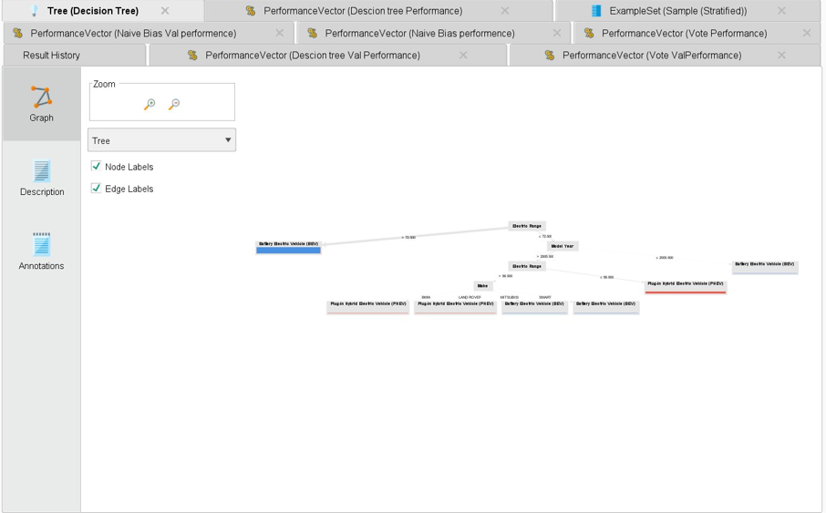
Figure 5.3: Decision Tree visual diagram — root split at Electric Range > 72.5, confirming Electric Range as the dominant predictive feature.

5.3 Naive Bayes
Naive Bayes Test Accuracy was 99.60 Percent. Validation Accuracy was 99.64 Percent. The confusion matrix indicates that 75 PHEVs were misclassified as BEV more than the Decision Tree due to the violation of the independence of features assumption between Electric Range and Electric Vehicle Type.

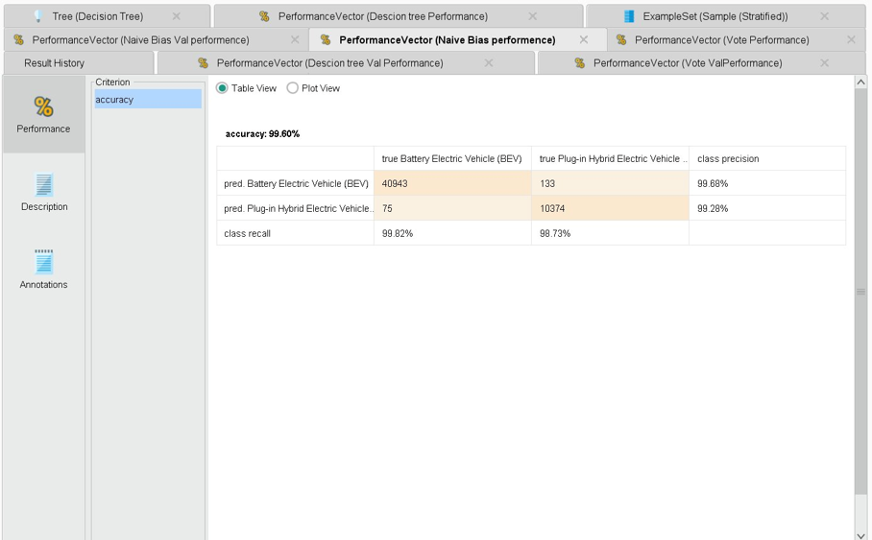
Figure 5.4: Naive Bayes test performance — 99.60% accuracy (75 PHEV misclassified).

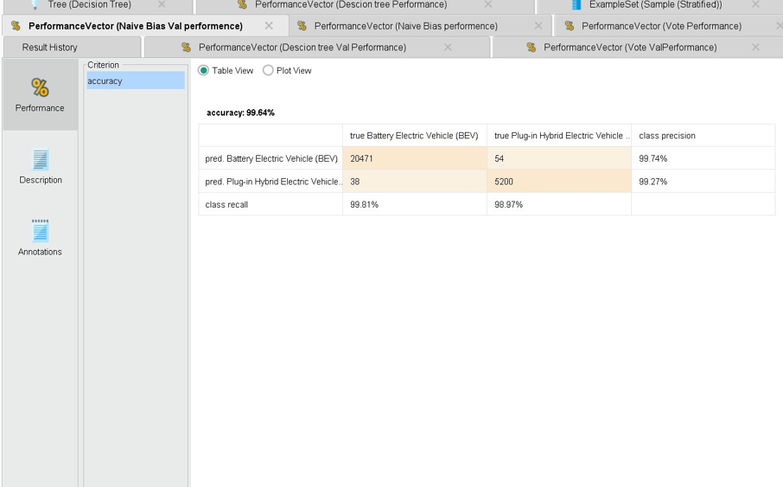
Figure 5.5: Naive Bayes validation performance — 99.64% accuracy.

5.4 Vote Ensemble
The Vote Ensemble achieved 99.73% test and 99.79% validation accuracy highest overall. The validation confusion matrix shows 0 PHEV misclassifications. Consistency across all models DT (99.73%/99.78%), NB (99.60%/99.64%), Vote (99.73%/99.79%) confirms no overfitting. Validation accuracy is marginally higher than test in every case, proving genuine generalisation.

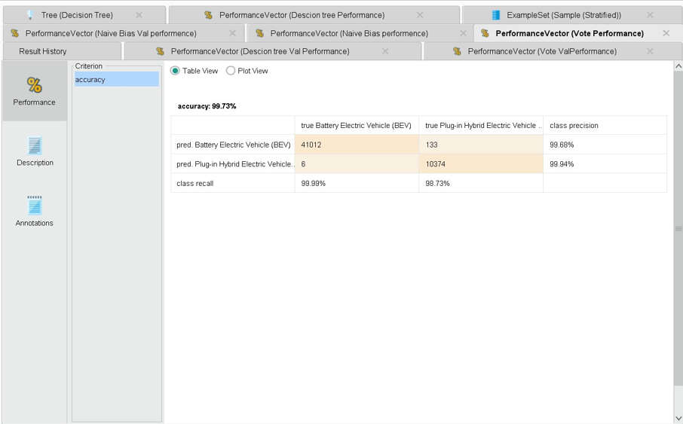
Figure 5.6: Vote Ensemble test performance — 99.73% accuracy.

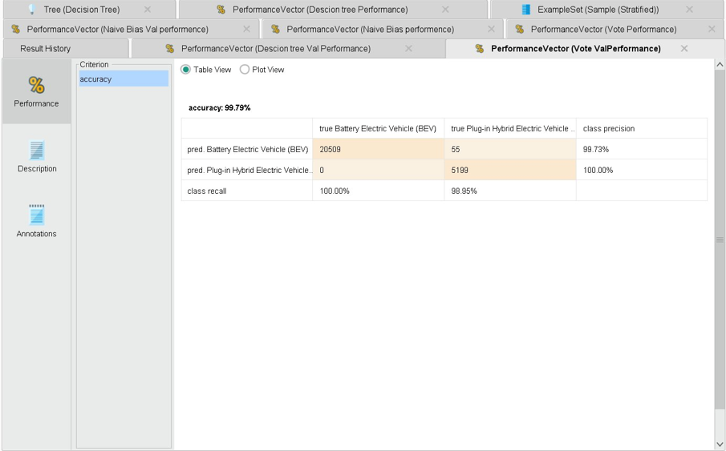
Figure 5.7: Vote Ensemble validation performance — 99.79%, 0 PHEV misclassifications on the untouched validation set.

5.5 Model Comparison

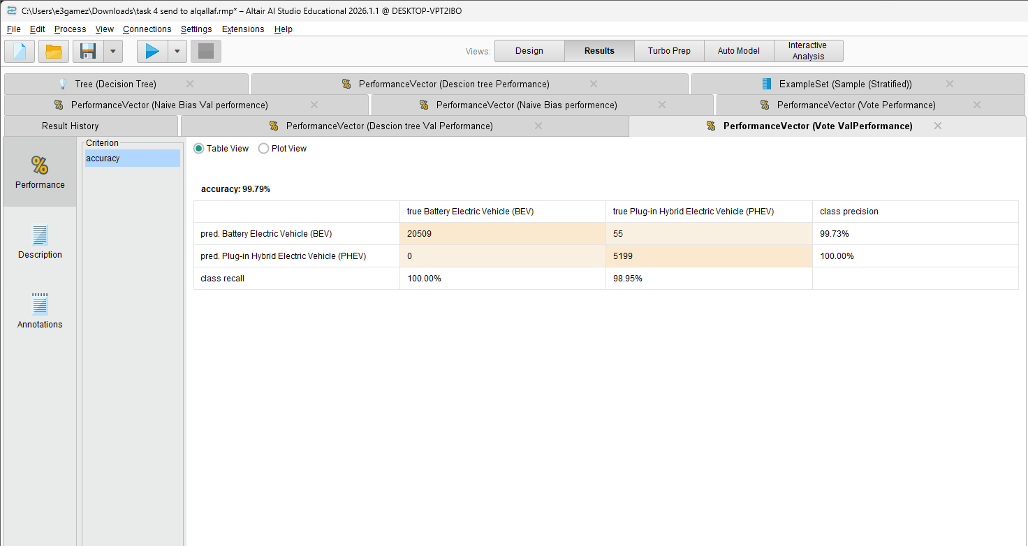
Table 5.1: Full model comparison. ★ = recommended model. Green = best performer.
The Vote Ensemble is recommended based on highest validation accuracy (99.79%) and zero PHEV misclassifications.

5.6 Complete RapidMiner Process
Figure 5.8 shows the complete pipeline from Task 3 cleaning through Task 4 model evaluation in Altair AI Studio.

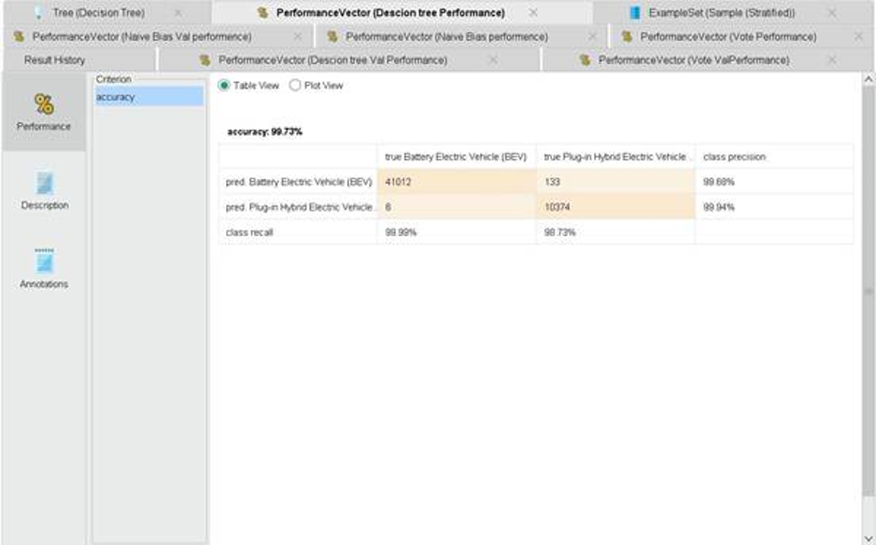
Figure 5.8: Complete RapidMiner pipeline — Task 3 cleaning (top row) and Task 4 model branches (bottom section).

Task 6 Inferences, Recommendations and Reflection

6.1 Model Comparison and Inferences
All three models had over 99% accuracy. The overall best validation model for the PHEV data set the vote ensemble achieved 99.79% accuracy with no misclassifications. The Decision Tree at the ensemble matched the accuracy of the test 99.73%. Moreover, it shows that electric range>72.5 is the most important feature. A little less effective 99.60% was the score of Naive Bayes because of violations of feature independence assumption.

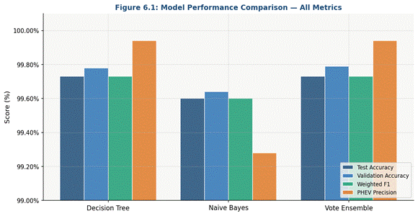
Figure 6.1: Model performance comparison across Test Accuracy, Validation Accuracy, Weighted F1 and PHEV Precision. Vote Ensemble leads on validation accuracy (99.79%).
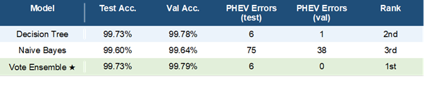
Table 6.1: Model comparison — ★ = recommended model (green = best performer)

6.2 Business Impact
These findings directly address EV production optimisation in Washington State. The 72.5-mile Electric Range threshold can define production boundaries between BEV and PHEV lines. The confirmed 80/20 distribution shows BEV adoption already dominates. CAFV eligibility classification supports policy makers in identifying incentive-qualifying vehicles.

6.3 Recommendations
Deploying The Vote Ensemble is recommended. Use of consensus from two independent algorithms and produced no PHEV misclassifications, the most important metric, because misclassifying PHEVs as BEVs misdirects production planning directly. Future work should include newer data, pricing features, and deep learning for edge cases.

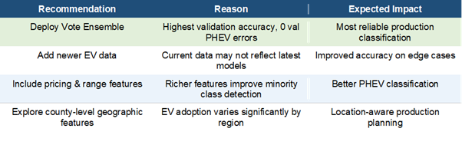
Table 6.2: Recommendations for improving the business problem

6.4 Reflection
This project shows the advantages of applying several data mining techniques on a particularly large real data set. A total of 157,670 zero Electric Range values exists i.e. PCA analysis reveals PC1 accounts for 99.9% numeric variance. The project successfully met its objectives as evidenced by the zero PHEV misclassifications. Further features engineering of geographic could give more production insights if repeated.

